Git Workflow - Branch Commands
# Source: AI Source: Provided by: [Data Path: Persons Table -> ID Column: 1, Name_En Column: Motasem Essam] -> From: [Chatgpt (GPT‑5 Mini)] on [2/19/2026]
In Git, branch commands are the commands you use to create, view, switch, merge, and delete branches. They let you manage separate lines of development so you can work on features or fixes independently without affecting the main code.

Let's break down each Git branch command with syntax, description, and an example so it’s crystal clear:

1️⃣ Create a New Branch
# Source: AI Source: Provided by: [Data Path: Persons Table -> ID Column: 1, Name_En Column: Motasem Essam] -> From: [Chatgpt (GPT‑5 Mini)] on [2/19/2026]
- Syntax:
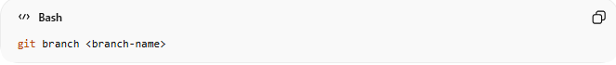
git branch <branch-name>
- Description: Creates a new branch with the given name. You stay on the current branch; it does not switch you automatically.
- Example:
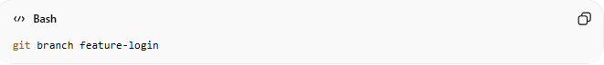
git branch feature-login
Creates a branch called feature-login but you remain on main.

2️⃣ Switch to a Branch

Method 1: Using git checkout
# Source: AI Source: Provided by: [Data Path: Persons Table -> ID Column: 1, Name_En Column: Motasem Essam] -> From: [Chatgpt (GPT‑5 Mini)] on [2/19/2026]
- Syntax:
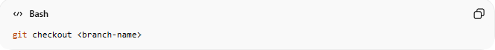
git checkout <branch-name>
- Description:
Switches your working directory to the specified branch so you can start working there.
- Example:
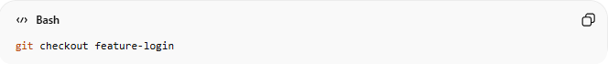
git checkout feature-login
Moves you from main to feature-login.

Method 2: Using git switch (recommended newer command)
# Source: AI Source: Provided by: [Data Path: Persons Table -> ID Column: 1, Name_En Column: Motasem Essam] -> From: [Chatgpt (GPT‑5 Mini)] on [2/19/2026]
- Syntax:
git switch <branch-name>
- Description:
A more modern and intuitive command to switch branches. Works the same as git checkout for switching branches, but avoids confusion with other uses of checkout.
- Example:
git switch feature-login
Moves you from main to feature-login.

3️⃣ Create and Switch at the Same Time
# Source: AI Source: Provided by: [Data Path: Persons Table -> ID Column: 1, Name_En Column: Motasem Essam] -> From: [Chatgpt (GPT‑5 Mini)] on [2/19/2026]

Method 1: Using git checkout -b
# Source: AI Source: Provided by: [Data Path: Persons Table -> ID Column: 1, Name_En Column: Motasem Essam] -> From: [Chatgpt (GPT‑5 Mini)] on [2/19/2026]
- Syntax:
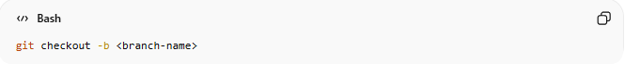
git checkout -b <branch-name>
- Description:
Creates a new branch and immediately switches to it in one step.
- Example:
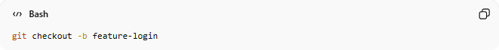
git checkout -b feature-login
Creates feature-login and switches you to that branch, ready to work.

Method 2: Using git switch -c (newer command)
# Source: AI Source: Provided by: [Data Path: Persons Table -> ID Column: 1, Name_En Column: Motasem Essam] -> From: [Chatgpt (GPT‑5 Mini)] on [2/19/2026]
- Syntax:
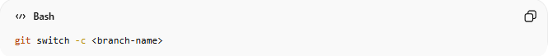
git switch -c <branch-name>
- Description:
A modern alternative to git checkout -b. Creates a new branch and switches to it immediately.
- Example:
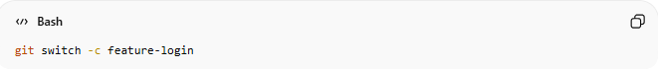
git switch -c feature-login
Creates feature-login and moves you onto it, ready to start working.

4️⃣ List Branches
# Source: AI Source: Provided by: [Data Path: Persons Table -> ID Column: 1, Name_En Column: Motasem Essam] -> From: [Chatgpt (GPT‑5 Mini)] on [2/19/2026]
- Syntax:
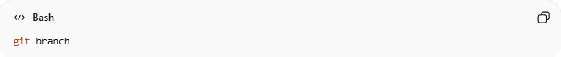
git branch
- Description: Lists all branches in your repository. The current branch is marked with *.
- Example:
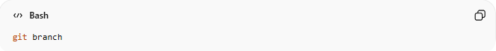
git branch
Output:
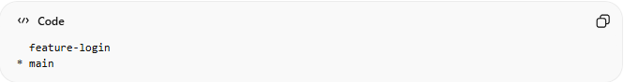
feature-login
* main
Shows two branches; you are currently on main.

5️⃣ Compare Branches

Method 1: Single-space diff (less common / includes working tree)
# Source: AI Source: Provided by: [Data Path: Persons Table -> ID Column: 1, Name_En Column: Motasem Essam] -> From: [Chatgpt (GPT‑5 Mini)] on [2/19/2026]
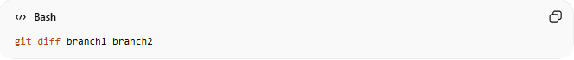
git diff branch1 branch2
Example:
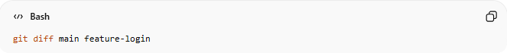
git diff main feature-login
- Compares the contents of the branches along with any unstaged changes in your working directory.
- Can appear empty if there are no differences in the working tree.

Method 2: Double-dot diff (recommended)
# Source: AI Source: Provided by: [Data Path: Persons Table -> ID Column: 1, Name_En Column: Motasem Essam] -> From: [Chatgpt (GPT‑5 Mini)] on [2/19/2026]
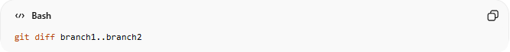
git diff branch1..branch2
Example:
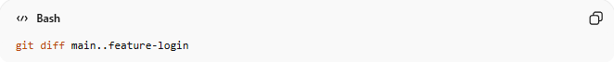
git diff main..feature-login
- Shows only the changes/commits that exist in feature-login but not in main.
- Cleaner and easier to understand when branches diverge.

Method 3: Show only file names that changed
# Source: AI Source: Provided by: [Data Path: Persons Table -> ID Column: 1, Name_En Column: Motasem Essam] -> From: [Chatgpt (GPT‑5 Mini)] on [2/19/2026]
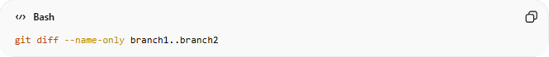
git diff --name-only branch1..branch2
Example:
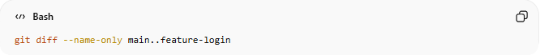
git diff --name-only main..feature-login
- Lists only the files that differ between the branches.
- Useful when you want a quick overview of affected files.

Method 4: Show summary of changes (insertions/deletions)
# Source: AI Source: Provided by: [Data Path: Persons Table -> ID Column: 1, Name_En Column: Motasem Essam] -> From: [Chatgpt (GPT‑5 Mini)] on [2/19/2026]
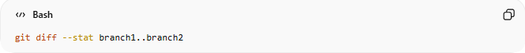
git diff --stat branch1..branch2
Example:
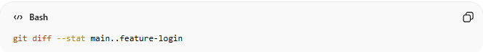
git diff --stat main..feature-login
- Shows a summary of changes including number of insertions, deletions, and files changed.
- Great for a quick sense of branch differences without seeing full content.

✅ Tip: For a full visual overview, you can also use GUI tools like VS Code, GitKraken, or GitHub’s branch compare.

6️⃣ Merge a Branch
# Source: AI Source: Provided by: [Data Path: Persons Table -> ID Column: 1, Name_En Column: Motasem Essam] -> From: [Chatgpt (GPT‑5 Mini)] on [2/19/2026]
- Syntax:
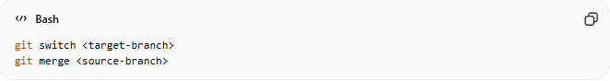
git switch <target-branch>
git merge <source-branch>
- Description: Merges changes from the source-branch into the target-branch. Conflicts may need resolving.
- Example:
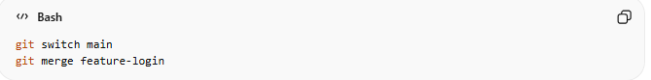
git switch main
git merge feature-login
Combines feature-login changes into main.

7️⃣ Delete a Branch
# Source: AI Source: Provided by: [Data Path: Persons Table -> ID Column: 1, Name_En Column: Motasem Essam] -> From: [Chatgpt (GPT‑5 Mini)] on [2/19/2026]
- Syntax:
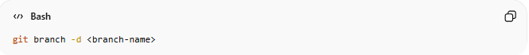
git branch -d <branch-name>
- Description: Deletes a branch that has been merged. Use -D to force delete even if it’s unmerged.
- Example:

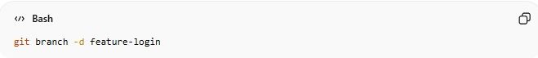
git branch -d feature-login
Removes the feature-login branch from your repository.

Example

1️⃣ Create a New Branch
# Source: ScreenShots Source: Provided by: [Persons Table -> ID Column: 1, Name_En Column: Motasem Essam] -> Tool: [Lightshot Program] -> From [Windows] on [2/19/2026]
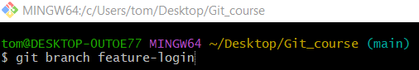
git branch feature-login

2️⃣ Switch to a Branch

Method 1: Using git checkout
# Source: ScreenShots Source: Provided by: [Persons Table -> ID Column: 1, Name_En Column: Motasem Essam] -> Tool: [Lightshot Program] -> From [Windows] on [2/19/2026]
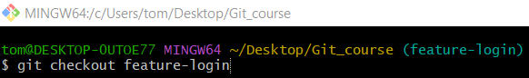
git checkout feature-login

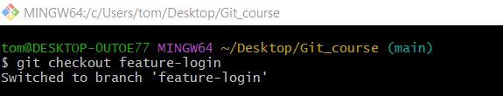

Method 2: Using git switch
# Source: ScreenShots Source: Provided by: [Persons Table -> ID Column: 1, Name_En Column: Motasem Essam] -> Tool: [Lightshot Program] -> From [Windows] on [2/19/2026]
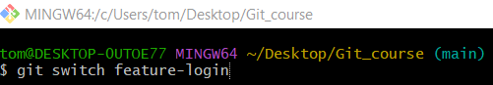
git switch feature-login
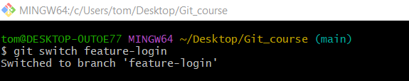

3️⃣ Create and Switch at the Same Time

Method 1: Using git checkout -b
# Source: ScreenShots Source: Provided by: [Persons Table -> ID Column: 1, Name_En Column: Motasem Essam] -> Tool: [Lightshot Program] -> From [Windows] on [2/19/2026]
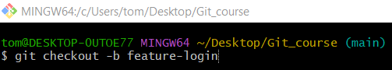
git checkout -b feature-login
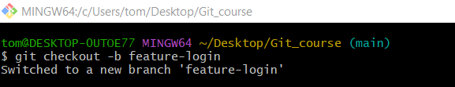

Method 2: Using git switch -c
# Source: ScreenShots Source: Provided by: [Persons Table -> ID Column: 1, Name_En Column: Motasem Essam] -> Tool: [Lightshot Program] -> From [Windows] on [2/19/2026]
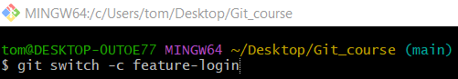
git switch -c feature-login
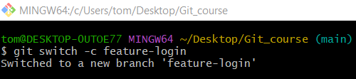

4️⃣ List Branches
# Source: ScreenShots Source: Provided by: [Persons Table -> ID Column: 1, Name_En Column: Motasem Essam] -> Tool: [Lightshot Program] -> From [Windows] on [2/19/2026]
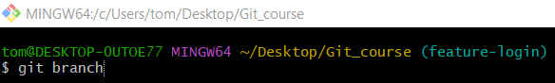
git branch
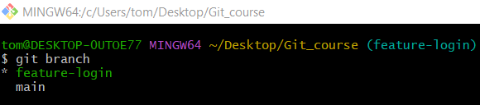

5️⃣ Compare Branches
# Source: ScreenShots Source: Provided by: [Persons Table -> ID Column: 1, Name_En Column: Motasem Essam] -> Tool: [Lightshot Program] -> From [Windows] on [2/19/2026]
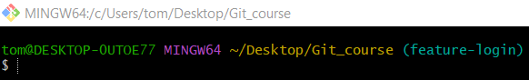
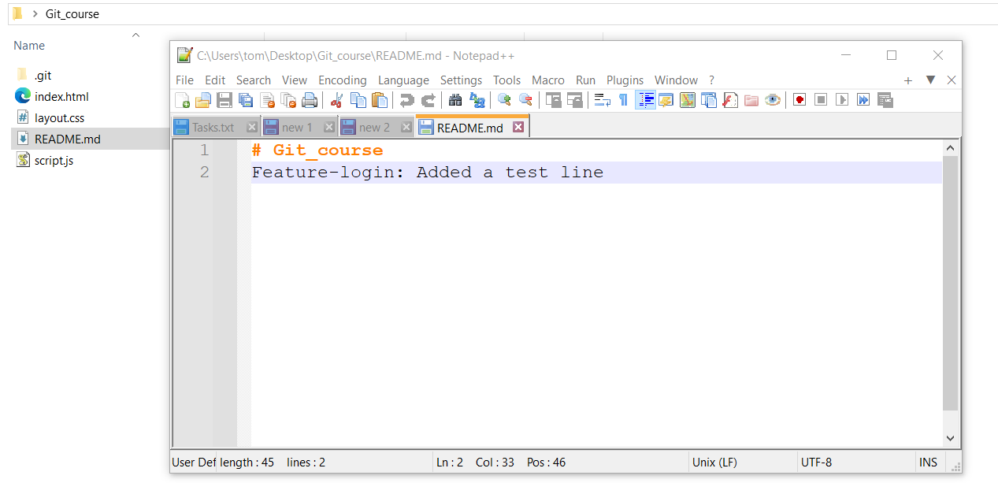
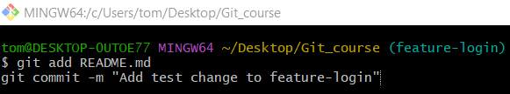
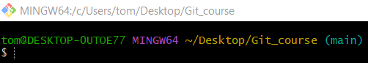
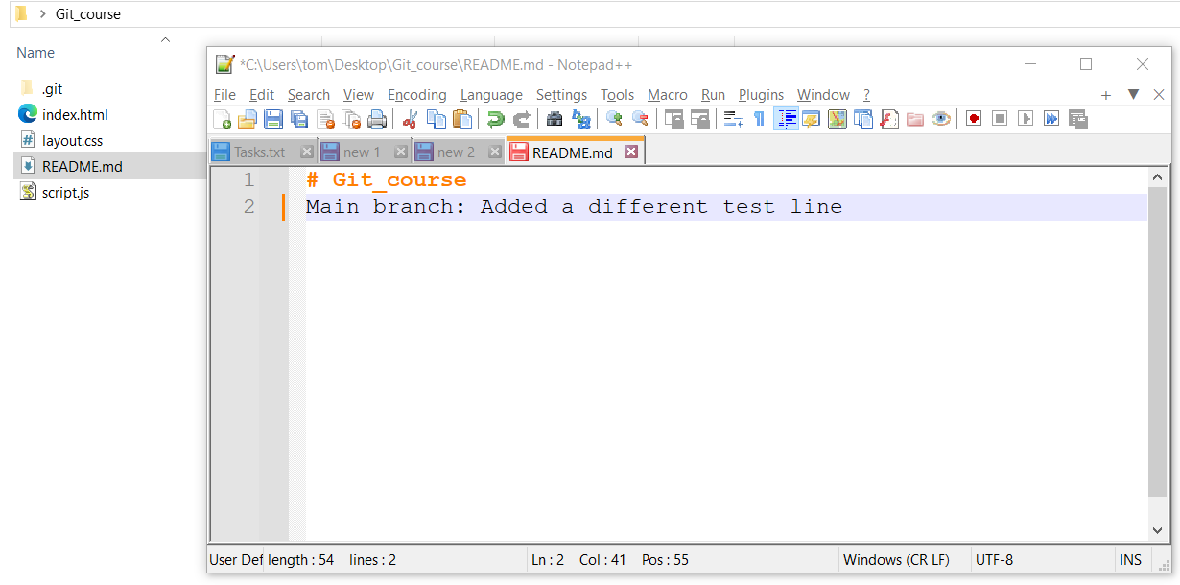
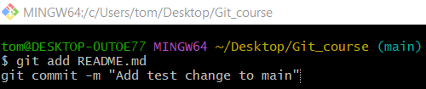

Method 1: Single-space diff
# Source: ScreenShots Source: Provided by: [Persons Table -> ID Column: 1, Name_En Column: Motasem Essam] -> Tool: [Lightshot Program] -> From [Windows] on [2/19/2026]
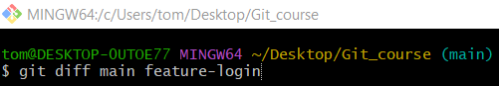
git diff main feature-login
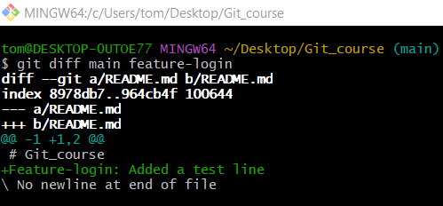

Method 2: Double-dot diff
# Source: ScreenShots Source: Provided by: [Persons Table -> ID Column: 1, Name_En Column: Motasem Essam] -> Tool: [Lightshot Program] -> From [Windows] on [2/19/2026]
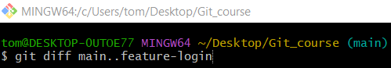
git diff main..feature-login

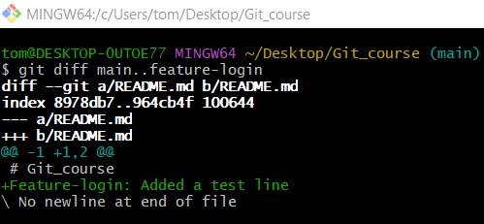

Method 3: Show only file names that changed
# Source: ScreenShots Source: Provided by: [Persons Table -> ID Column: 1, Name_En Column: Motasem Essam] -> Tool: [Lightshot Program] -> From [Windows] on [2/19/2026]
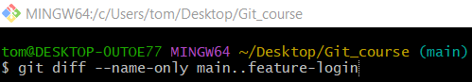
git diff --name-only main..feature-login
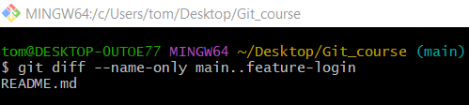

Method 4: Show summary of changes
# Source: ScreenShots Source: Provided by: [Persons Table -> ID Column: 1, Name_En Column: Motasem Essam] -> Tool: [Lightshot Program] -> From [Windows] on [2/19/2026]
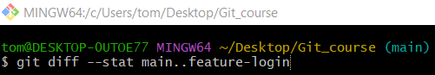
git diff --stat main..feature-login
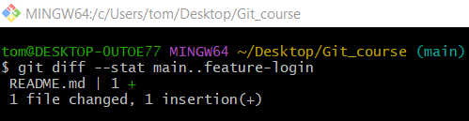

6️⃣ Merge a Branch
# Source: ScreenShots Source: Provided by: [Persons Table -> ID Column: 1, Name_En Column: Motasem Essam] -> Tool: [Lightshot Program] -> From [Windows] on [2/19/2026]
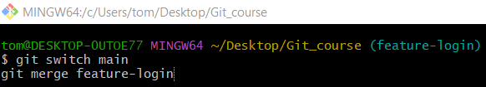
git switch main
git merge feature-login
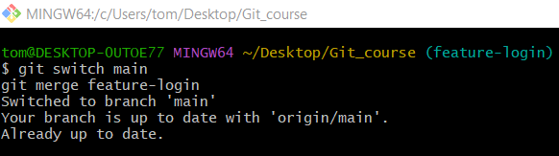

7️⃣ Delete a Branch
# Source: ScreenShots Source: Provided by: [Persons Table -> ID Column: 1, Name_En Column: Motasem Essam] -> Tool: [Lightshot Program] -> From [Windows] on [2/19/2026]
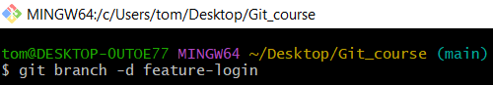
git branch -d feature-login
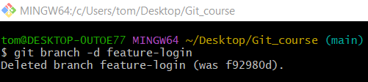
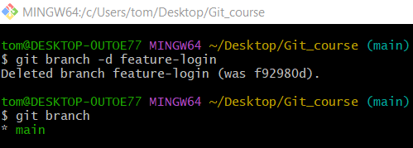

Create branch in Visual Studio Code
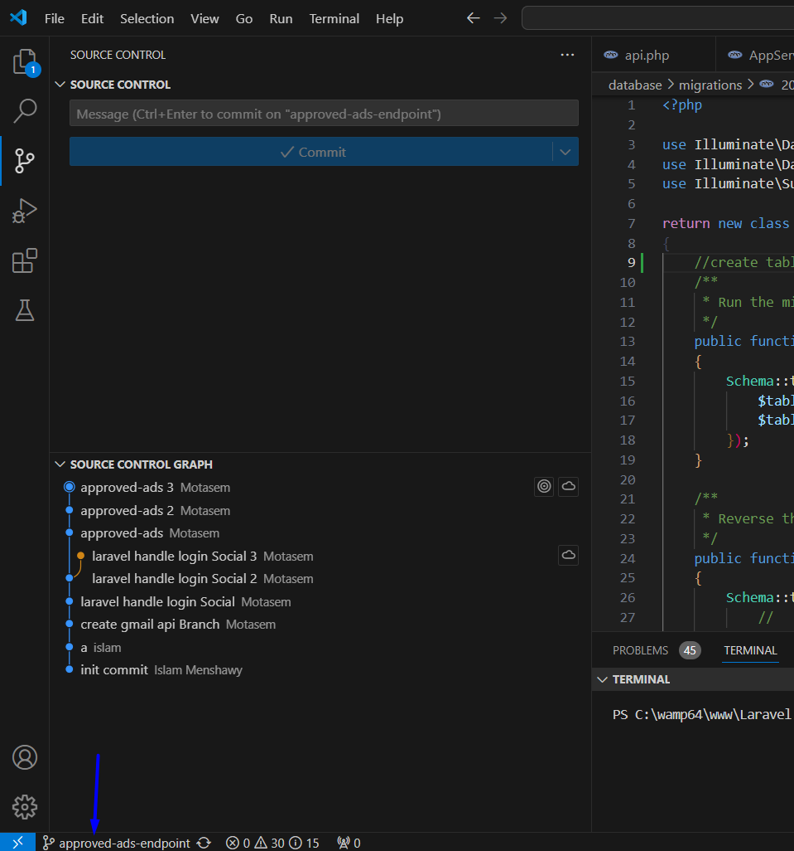
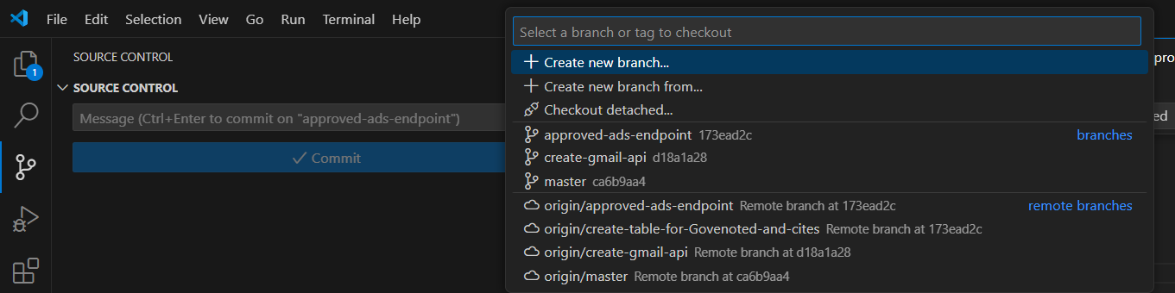
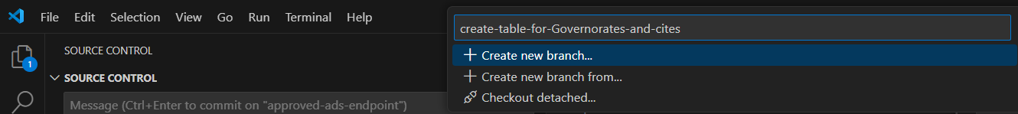
create-table-for-Governorates-and-cites
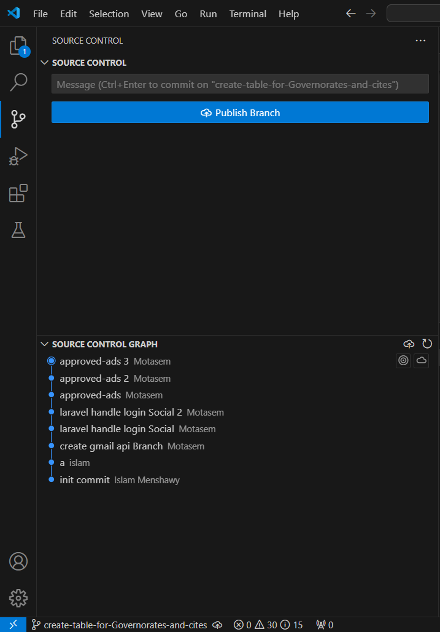

git push --set-upstream origin create-table-for-Governorates-and-cites
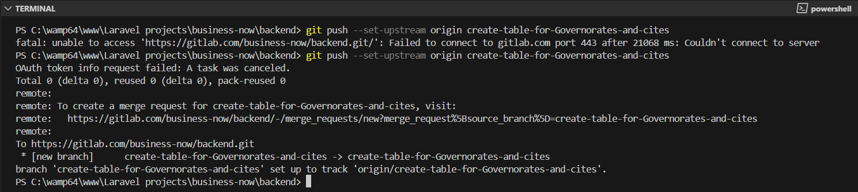
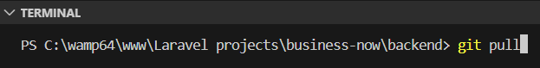
git pull
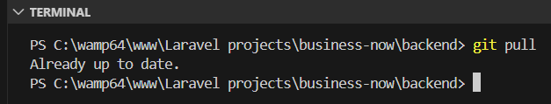

Create branch with jira

Step 1 open jira
# Source: ScreenShots Source: Provided by: [Persons Table -> ID Column: 1, Name_En Column: Motasem Essam] -> Tool: [Lightshot Program] -> From [Windows] on [2/19/2026]
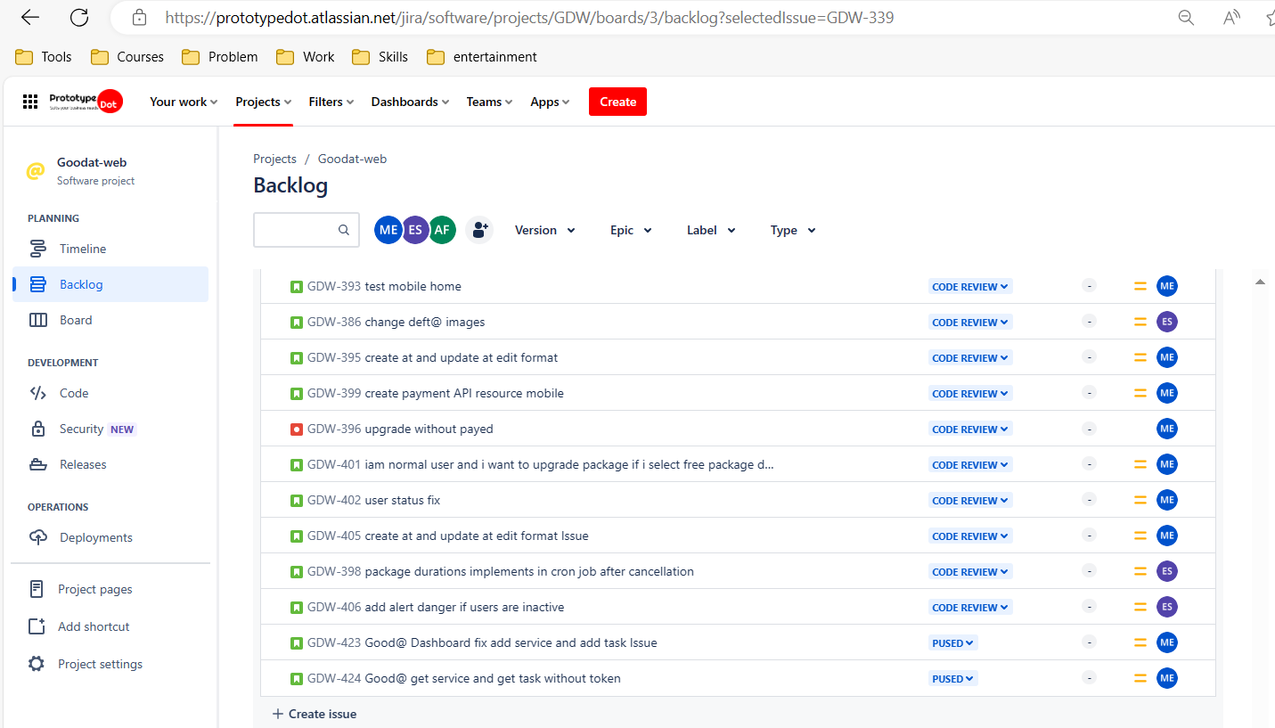

Step 2 create ticket
# Source: ScreenShots Source: Provided by: [Persons Table -> ID Column: 1, Name_En Column: Motasem Essam] -> Tool: [Lightshot Program] -> From [Windows] on [2/19/2026]
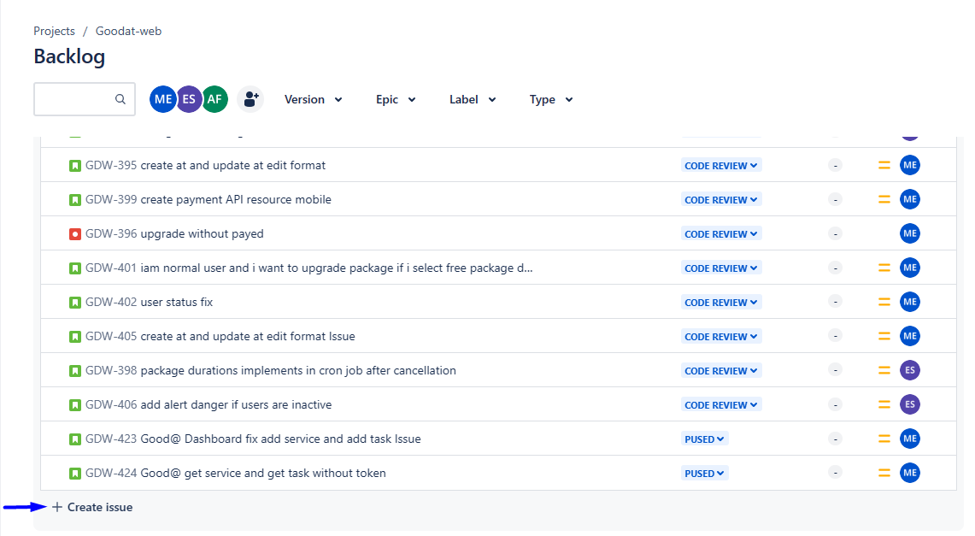


Step 3 create branch
# Source: ScreenShots Source: Provided by: [Persons Table -> ID Column: 1, Name_En Column: Motasem Essam] -> Tool: [Lightshot Program] -> From [Windows] on [2/19/2026]
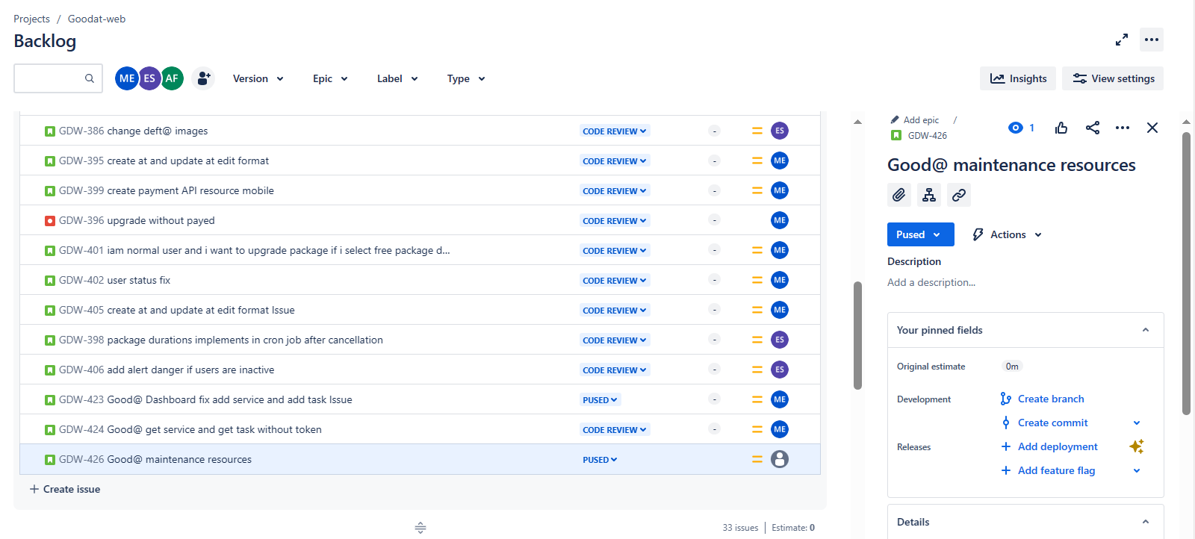
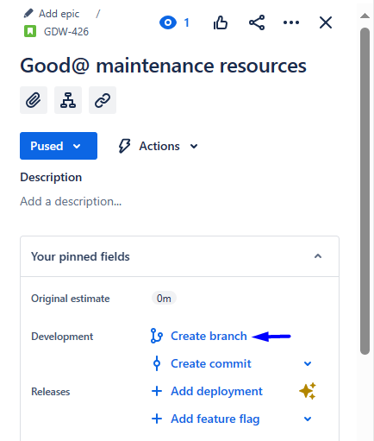
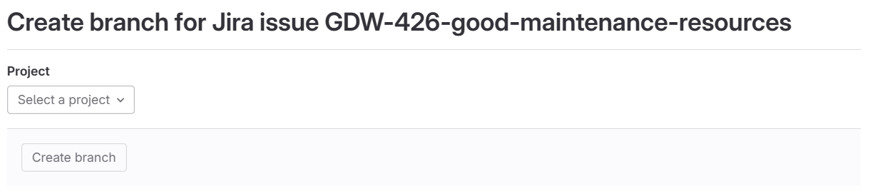
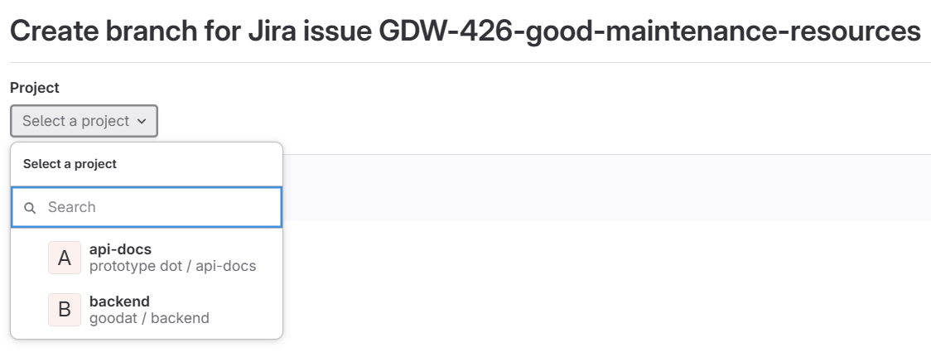
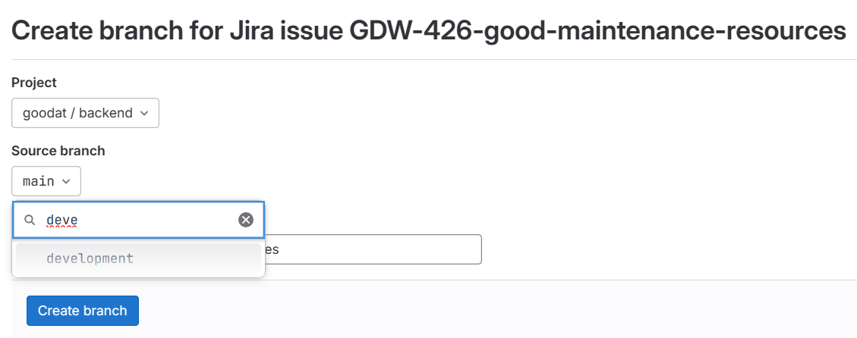
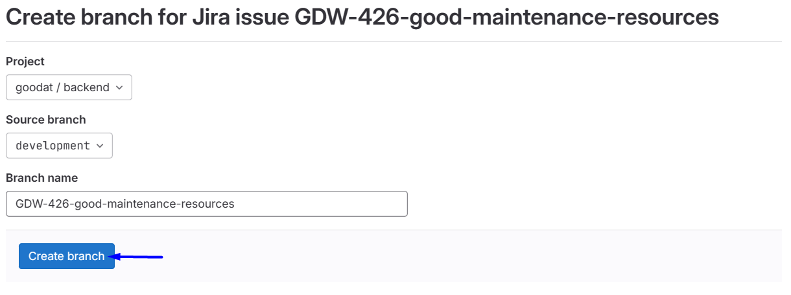
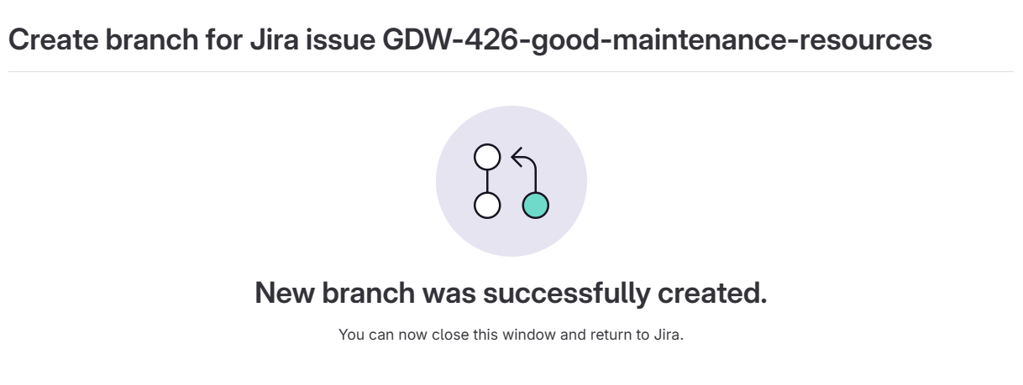
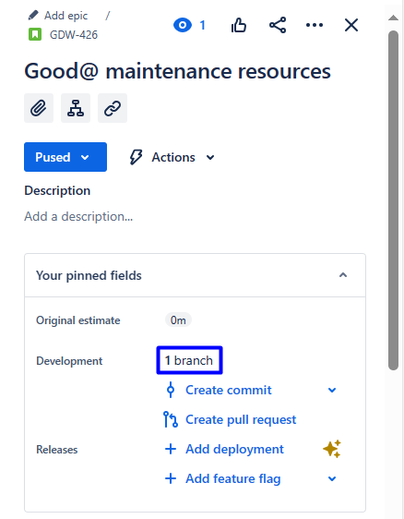

Step 4 open branch
# Source: ScreenShots Source: Provided by: [Persons Table -> ID Column: 1, Name_En Column: Motasem Essam] -> Tool: [Lightshot Program] -> From [Windows] on [2/19/2026]
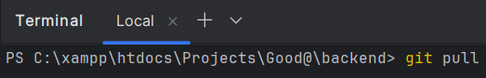
git pull
